**Robomaster Tello Talent – ArUco Marker Detection and Video Recording**

*Report by: Ayemon Baraka*

*Department of ECE, UNLV*

The purpose of this project is utilizing the Robomaster Tello Talent, an advanced programmable drone, and ArUco markers. The project involves the Tello Talent performing a series of actions, including taking off, displaying messages on its matrix, rotating 360 degrees, detecting ArUco markers, recording a video, and finally landing. This report provides a comprehensive overview of the project's work procedure, components used, and detailed explanation of each step.

**Work Procedure:**

The project consists of the following steps:

1. Takeoff and Display "Hello":

The Tello Talent initiates by taking off from a stable surface. Once airborne, the drone's display matrix showcases the message "Hello." This action serves as an indication of successful takeoff.

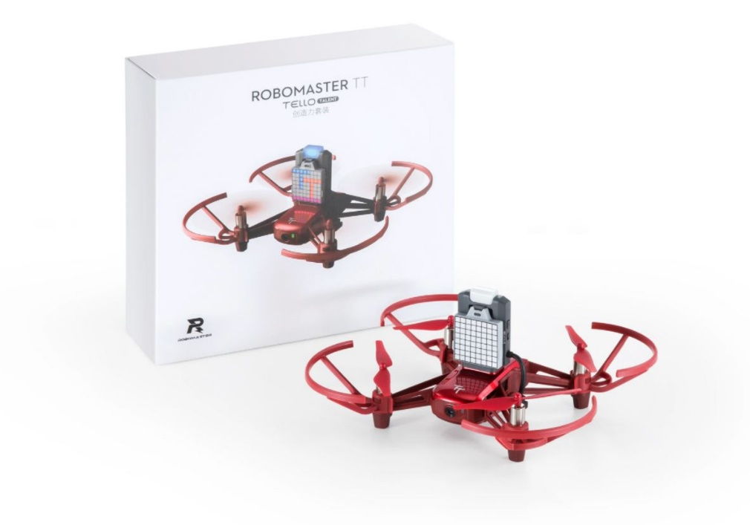

Figure : Robomaster Tello Talent

1. 360-Degree Rotation:

After displaying the greeting message, the Tello Talent proceeds to rotate 360 degrees horizontally. This rotation allows the drone to scan its surroundings effectively for the presence of an ArUco marker.

1. ArUco Marker Detection:

While rotating, the Tello Talent utilizes its built-in camera and computer vision techniques implemented using OpenCV in Python to search for ArUco markers within its field of view. ArUco markers are specific types of square markers with unique patterns that can be easily detected by computer vision systems.

1. Marker Detection Outcome:

When the Tello Talent fails to detect an ArUco marker, it updates its display matrix with a sad smiley face. Conversely, upon successfully detecting an ArUco marker, it updates its display matrix with a happy smiley face. Following the detection, the Tello Talent continues its 360-degree rotation while simultaneously initiating the video recording process.

Figure : ArUco Markers

1. Video Recording:

While recording the video, the Tello Talent captures a visual feed using its onboard camera. The continuous 360-degree rotation ensures a comprehensive view of the surroundings during the recording process.

Once the video recording is complete, the Tello Talent lands safely. This action concludes the project's sequence of operations.

**Components:**

The components used in this project are:

1. Robomaster Tello Talent
2. ArUco Markers

**Practical Implementation with Code:**

1. Setting up Robomaster Tello Talent

Turn on the Robomaster Tello Talent and ensure that your PC is connected to the robot using direct connection mode.

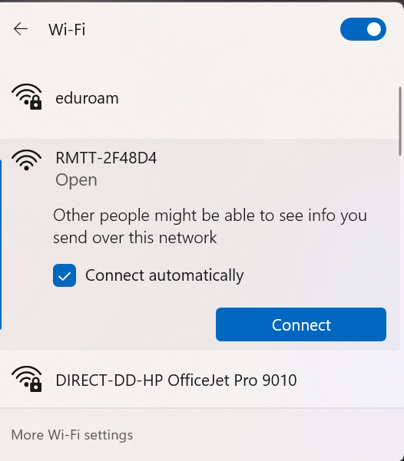

Figure : Direct Connection

1. Install Python:

Download and install Python on your computer. Visit the official Python website (https://www.python.org) and download Python 3.8. Follow the installation instructions provided for your specific operating system.

1. Clone the GitHub Repository:

Open a terminal or command prompt on your computer and navigate to the directory where you want to clone the project repository. Execute the following command to clone the repository:

*git clone https://github.com/AyemonBaraka/Robomaster_TT_Aruco_Marker_Detection.git*

This will create a local copy of the project repository on your computer. Alternatively, you can download the project code directly from the GitHub repository.

1. Install requirements:

Navigate to the cloned repository directory and Install the required Python packages by executing the following command:

*pip install -r requirements.txt*

1. Run the code:

Make sure your Tello Talent is turned on and connected to your computer. Execute the following command to run the project code.

*python main.py*

This will start the program and initiate the procedure.

Links:

Code: <https://github.com/AyemonBaraka/Robomaster_TT_Aruco_Marker_Detection>

Demo Video: <https://youtu.be/HPvbXHlDvX0>

Video Recorded by Robomaster Tello Talent in AISL Summer 2023 camp during Demo:

<https://youtu.be/DsnT45xsGOg>